Quotation - Massivit 1800 3D Printer

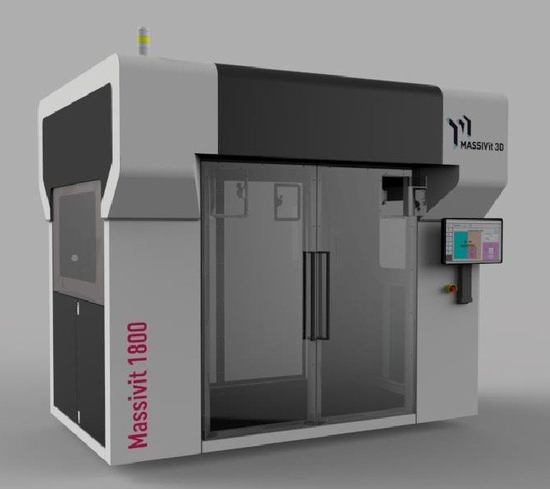

|  |  |
| --- | --- |
| Date | April 19, 2016 |
| Company name | Big Pond  Matt Huner  +61-411-793-322  [matthuber@bigpond.com](mailto:matthuber@bigpond.com) |

Dear Matt,

Thank you for your interest in our products. We are pleased to offer you a 3D-printing system for the building of 3D objects directly from digital data. Following you will find our quotation and our general terms and conditions. We would be happy to discuss the quotation in more detail. For further questions please do not hesitate to contact me.

Kind regards,

Erez Zimerman

[erez@massivit.com](mailto:erez@massivit.com)

Mobile: +972-54-6674325

*General Terms*

1. This offer is valid for a period of 30 days from the date above.
2. All prices are in USD and do not include any applicable tax or VAT.
3. Shipping Terms: Ex-Works – Lod, Israel. Insurance by customer. Shipping prices not included.
4. Estimated Delivery: up to 90 days from receiving a signed order and down payment
5. No CAD or 3D modeling software is supplied with the machine.
6. Manufacturers’ warranty covers all parts and labor except print heads. Printing heads are expected to require about 4 replacements per year and are available as new or refurbished parts. (Refurbish print head $1,800 , New print head $5,600)
7. The uptime kit includes a printing head and a Dimengel pump, nozzle tip and other parts.
8. No additional equipment or devices are supplied other than items specifically listed in this quote.

*Note*

For estimating site preparations, please consult your local providers, based on the attached site preparation guide.

# Printer Specifications

|  |  |
| --- | --- |
| Print configuration | 2 printing heads capable of printing 2 different objects simultaneously |
| Print volume | W x L x H: 1.18 x1.5 x 1.8m / ~4 x 5 x 6 feet |
| Maximum Object Weight | Max. object weight 150kg /330 lbs |
| Productivity | Up to 35cm/14 inch per hour on z-axis  Print speed dependent on object's geometric shape, object size & print mode |
| Printing material | Dimengel® - Massivit proprietary UV LED Curing Gel |
| Workflow and software | *Software on machine*: Massivit proprietary front end software  *Massivit Smart*:* Massivit proprietary software for slicing / pre-press file preparation  Included Features: Scale, rotate, slice, support generation**  to be ran on separate PC (not included)  Input format: STL |
| System Dimensions | W x L x H: 3.1 x 2.2 x 2.8 meters / 10.17 x 7.2 x 9.1 feet |
| System weight | Unpacked ~2500kg / 5511 lbs.  Packed ~3000kg / 6613 lbs. |

* Computer not included

** Features not included – file repair & healing, object design & editing, cut; solution may include several steps and several tools and not necessarily one integrated solution. Some features may be delivered through online tools.

|  |  |  |
| --- | --- | --- |
| **Accepted and Agreed this day of** [date] |  |  |
|  |  |  |
| Company name: |  |  |
|  |  |  |
| Signed by: |  |  |
|  |  |  |
| Signature: |  |  |

**Massivit Bank Details:**

Bank: Leumi Le Israel Bank  
Branch NO: 968  
Account: 628500/68  
Swift: LUMIILITXXX  
IBAN: IL62 0109 6800 0006 2850 068

Branch name: Business Branch Har Hotzvim

Address: Kiryat Hamada 3, Jerusalem, Israel